**Distributed DBMS and query processing**

Distributed database is a collection of multiple logically interrelated databases distributed over a computer network.

Distributed database management system (DDBMS) is a software system that manages a distributed database while making the distribution transparent to the user.

It is a system to process unit of execution in a distributed manner.

In these there are two main types of multiprocessor systems:

- shared memory: share secondary storage and also share primary memory (tightly coupled)

- shared secondary storage: loosely coupled

The major purpose of distributed dbms include:

- decentralization

- economic processing

In a distributed database system, processing a query comprises of optimization at both the global and the local level. The query enters the database system at the client or controlling site. Here, the user is validated, the query is checked, translated, and optimized at a global level.

The architecture can be represented as −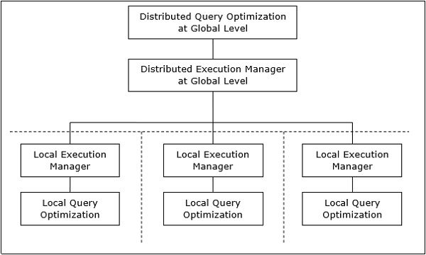

The process of mapping global queries to local ones can be realized as follows −

• The tables required in a global query have fragments distributed across multiple sites. The local databases have information only about local data. The controlling site uses the global data dictionary to gather information about the distribution and reconstructs the global view from the fragments.

• If there is no replication, the global optimizer runs local queries at the sites where the fragments are stored. If there is replication, the global optimizer selects the site based upon communication cost, workload, and server speed.

• The global optimizer generates a distributed execution plan so that least amount of data transfer occurs across the sites. The plan states the location of the fragments, order in which query steps needs to be executed and the processes involved in transferring intermediate results.

• The local queries are optimized by the local database servers. Finally, the local query results are merged together through union operation in case of horizontal fragments and join operation for vertical fragments.

Distributed query optimization requires evaluation of a large number of query trees each of which produce the required results of a query. This is primarily due to the presence of large amount of replicated and fragmented data. Hence, the target is to find an optimal solution instead of the best solution.

The main issues for distributed query optimization are −

* Optimal utilization of resources in the distributed system.
* Query trading.
* Reduction of solution space of the query.

A distributed system has a number of database servers in the various sites to perform the operations pertaining to a query. Following are the approaches for optimal resource utilization −

Operation Shipping − In operation shipping, the operation is run at the site where the data is stored and not at the client site. The results are then transferred to the client site. This is appropriate for operations where the operands are available at the same site. Example: Select and Project operations.

Data Shipping − In data shipping, the data fragments are transferred to the database server, where the operations are executed. This is used in operations where the operands are distributed at different sites. This is also appropriate in systems where the communication costs are low, and local processors are much slower than the client server.

Hybrid Shipping − This is a combination of data and operation shipping. Here, data fragments are transferred to the high-speed processors, where the operation runs. The results are then sent to the client site.

